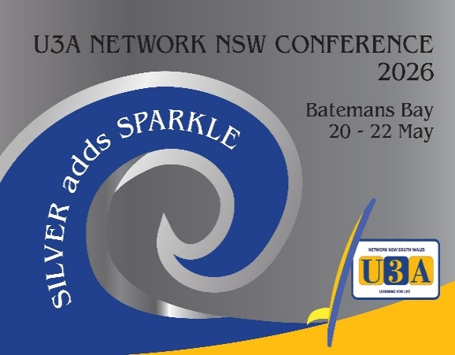  Your Conference Committee has partnered with four accommodation providers who are offering either a special conference price or 10% discount on advertised prices for conference attendees.  To obtain the special conference price please call the hotels direct and ask for the U3A Conference Price.  - Bay Breeze Boutique Accommodation, www.baybreezemotel.com.au  Ph 02 4472 7222;  - Mariners On The Waterfront, www.marinerswaterfront.com.au  Ph 02 4472 6222;  - Zorba Waterfront Motel, www.zorbamotel.com.au  Ph 02 4472 4804.  - Araluen Motor Lodge at Batehaven, www.araluenmotorlodge.com.au Ph 02 44726266, five minutes drive south of town.  - There is ample parking at the club and the courtesy bus runs in the evening. | U3A Network NSW Conference  20th to 22nd May 2026.  Soldiers Club, Batemans Bay.  Conference starts with the Welcome Dinner on the Wednesday evening.  Registration and payment via Trybooking  Https://www.trybooking.com/events/landing/1503823?embed  Keynote Speakers:  Estella Hutchinson, a Canberra based stand-up comedian and end of life doula who is on a mission to make conversation about death and dying comfortable and respectful.  Dr Merv Bendle: Merv has enjoyed a varied career, retiring in 2013 as Senior Lecturer in History & Communications at James Cook University. Previously he taught in public and private secondary schools, was executive officer of an adult education centre, and worked at a senior level in the financial, housing, and social policy areas in the public sector. At Batemans Bay U3A, he has offered a range of U3A courses on Cultural History  Bill Radley: Our psychologist U3A member has a long history of helping people in their struggles through life. However, in later years he discovered that overcoming problems in life does not make people happy. Happiness, he discovered, is not just an absence of problems in life. Happiness requires a very different set of skills.

