Wednesday 20 May
5.00 pm Registration Desk Open
Meet and Greet & Bar Open
5.45 pm Move in for dinner
6.00 pm Conference Opening –
Mayoral address
After Dinner Guest Speaker:
Estella Hutchinson – Laughing with Death

Thursday 21 May
U3A Today
8.00 am Guided Waterfront Stroll
Meet opposite Soldiers Club near the
silver “half-moon”
8.30 am Registration Desk Open
9.00 am MC Welcome & Housekeeping
Introduction to Stall Holders
9.30 am Keynote Speaker – Dr Mervyn Bendle Time Enough at Last – A Philosophy of Third Age Learning

PROGRAM

10.30 am Morning Tea
11.00 am Laurene Mulcahy
Network President
11.10 am Speaker – Bill Radley –
Silver Sparkle Happiness
12.00 noon Regional Workshop –
wear your regional colours

12.30 pm Lunch
1.30 pm Speaker from IT&T –
Privacy Legislation
2.10 pm Speaker - Catharine Routh
Digital Legacy
2.50 pm Speaker - Claire Beck
Member Wizard

3.30 pm Afternoon Tea
3.50 pm Speaker UOW
Mature Age Degrees
4.20 pm Speaker - Alex Gosman
Engaging Your Members

5.00 pm MC Close

Friday 22 May
Looking to the Future
8.00 am Guided Waterfront Stroll
Meet opposite Soldiers Club near the
silver “half-moon”
8.30 am Registration Desk Open
9.00 am Speaker Trica Pye - Tec Exec
Let’s talk AI
9.45 am Speaker - ClubMap
Succession Planning
10.30 am Committee Roles Workshop

11.10 am Morning Tea

11.30 am Speaker - Dr Mervyn Bendle –
Time Enough at Last - A Philosophy of Third Age Learning - Practical Aspects
12.15 pm Speaker - Bill Radley
Is your U3A happy?

1.00pm MC Close

Accommodation
Your Conference Committee has partnered with four accommodation providers who are offering either a special conference price, or 10% discount, on advertised prices for conference attendees.
To obtain the special conference price please call the hotels direct and ask for the U3A Conference Price.
- Bay Breeze Boutique Accommodation
www.baybreezemotel.com.au
Ph 02 44727222.
- Mariners on the Waterfront
www.marinerswaterfront.com.au
Ph 02 44726222.
- Zorba Waterfront Motel
www.zorbamotel.com.au
Ph 02 4472 4804.
- Araluen Motor Lodge Batehaven
www.araluenmotorlodge.com.au
Five minutes’ drive south of town.
Ph 02 44726266
There is ample parking at the Club and the Club courtesy bus runs in the evening.
For more accommodation information search “Accommodation Batemans Bay”
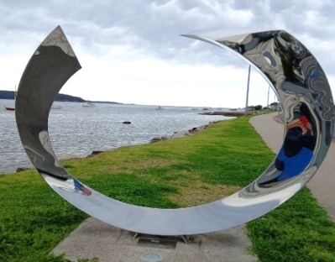

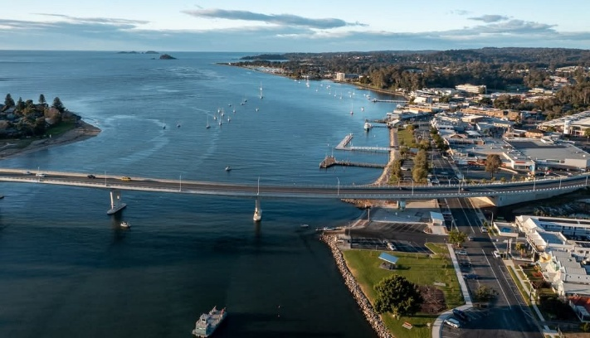
Cost
Conference & Dinner: $175
Dinner only: $65
Thursday only: $65
Friday only: $45

Registration and Payment
via the Trybooking website:
www.trybooking.com/events/landing/1503823
Or scan this QR code …


Hosted by
U3A Batemans Bay

20th – 22nd May 2026

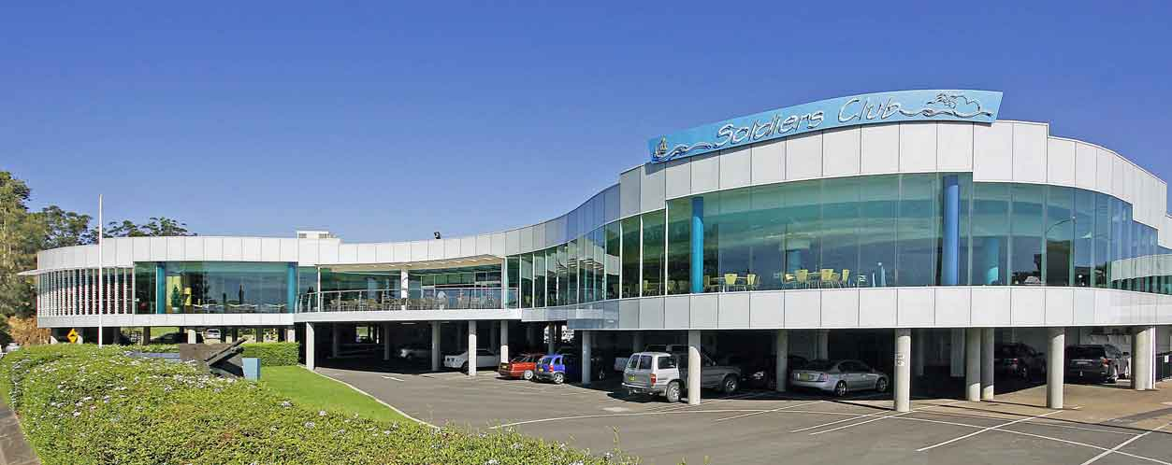
Batemans Bay Soldiers Club

Major Sponsor.

